Redding EAA Chapter 157 Steve Wallace Memorial Flight Training Scholarship
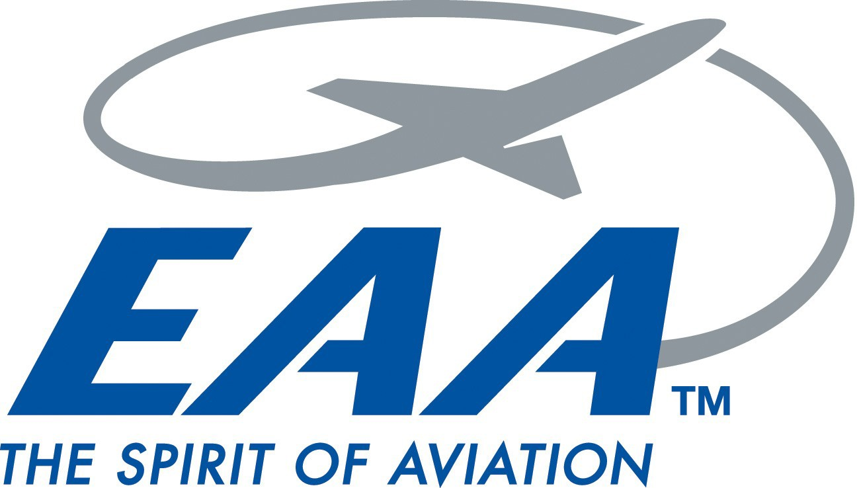

Redding EAA Chapter 157 is offering a $1000.00 aviation scholarship to a local person who is interested in obtaining his or her Sport Pilot, Recreational Pilot or Private Pilot's License. Redding EAA is looking for a qualified candidate who is interested in either furthering their pursuit to become a pilot as a career choice or to join the many recreational pilots who seek to keep alive the freedom to fly in the United States. This scholarship is named in remembrance of longtime EAA member Steve Wallace, who went west last year.

Eligibility
The applicant must be a resident of Shasta, Trinity, Siskiyou or Tehama Counties.

The applicant must have successfully passed the FAA Knowledge test and have soloed before money is awarded, but not necessarily before making application.

The applicant must be proficient in English. The applicant must be at least 16 years of age.
Applications must be received by the application deadline, August 31st, 2017. Winner will be notified of the judges decision by September 6th, 2017.

Application guidelines

The application must be completed if full using the attached form. Upon completion, mail original and three copies of the following:
- The application.
- Personal essay.
- Budget information.
- A current photograph.
- No more than three letters of recommendation.

Send packet to:
Redding EAA Chapter 157
P.O. Box 992353 Redding, CA 96099-2353

The application will be judged on the applicant's:
- Activities in and commitment to aviation.
- Ability to reach goals.
- Financial need as shown in the budget submitted.
- Personal essay.
- Letters of recommendation.

The applicant may be asked to meet with the Scholarship Committee for an interview.
Terms

If the recipient of the scholarship award does not complete the rating appropriate to the award within one year of the award date, the status will be reviewed. Special circumstances will be considered. Copies of the recipient's logbook shall be provided monthly, along with a monthly report from the instructor during this year. If the recipient's progress is not acceptable, all funds paid out must be reimbursed to Redding EAA Chapter 157 within 60 days of that decision.

The scholarship money will be paid directly to the flight school or independent flight instructor conducting the training. Receipts showing hours flown and signed by both student and instructor before funds are awarded.

